Quiz 3

Regression

In the regression equation Y = 21 - 3X, the slope is

A. 21

B. -21

C. 3

D. -3

In the regression equation Y = 21 - 3X, the slope is

A. 21

B. -21

C. 3

D. -3

1)

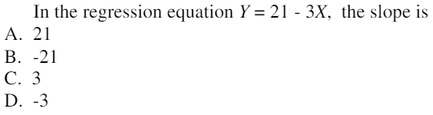

2)

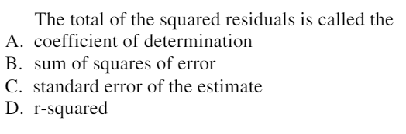

3)

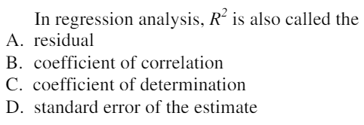

4)

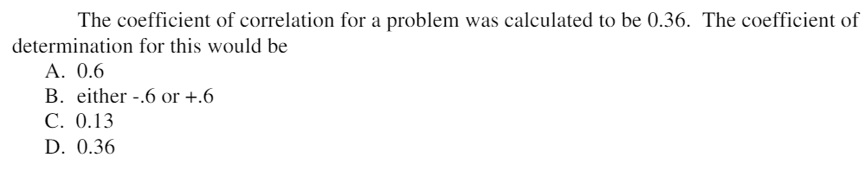

5)

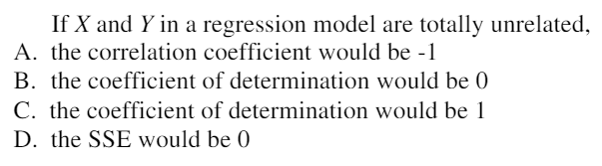

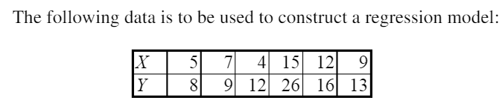

6)

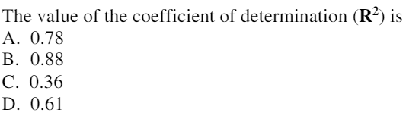

7)

